Kinnity - (KNTA)
Wednesday 11 March 2026
11:47

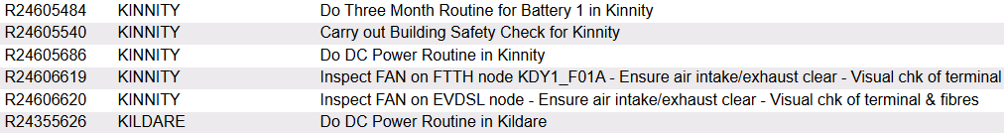

Please clean/replace filter on Nokia KNT-MSAN

Battery temperature: 13 °C

Overall Voltage: 53.99

Cell 1: 13.57
Cell 2:13.50
Cell 3: 13.54
Cell 4: 13.48

Rectifiers | 6
DC Power Load | 16.2
Boost Voltage | 54
Float Voltage | 53.79

Alarm Limits
Low Voltage | 47V
High Voltage | 58
High Load | 100%
High Temperature | 30 °C

Low Voltage, High Voltage, High Load and High Temperature alarms were tested, but only Low Voltage alarm was visible to SMC

